Worcester Polytechnic Institute

Computer Science Department

Prof. Wilson Wong

CS3733-D21 Project Iteration 4

User Manual

Team B: Burgundy Basilisks

Team Coach: Andrew Bonaventura

|  |  |  |
| --- | --- | --- |
| **Student** | **Position** | **GitHub** |
| Alex Bolduc | Assistant Software Engineer 2 | AxBolduc |
| Brian Francis | Project Owner | BCFrancis |
| Timothy Goon | Lead Software Engineer | T-Goon |
| Smera Gora | Algorithms Specialist | smeragora |
| Eric Heinemann | UI and Graphics Engineers | Ercman99 |
| Megan Letendre | Project Manager | meganletendre7 |
| William McDonald | Scrum Master | blobfish2000 |
| Jonathan Metcalf | Assistant Software Engineer 1 | JMetcalf01 |
| Suela Miloshi | Algorithms Specialist | suelamiloshi |
| Erin Perry | Documentation Analyst | emperry |
| Molly Sunray | Back-End Database Engineer | mdsunray34 |

GitHub Link: <https://github.com/CS3733-D21-Team-B>

Table of Contents

Chapter 1: Pathfinding 1

1.1 Setting Start and End Locations 1

1.1.1 Using the Map Nodes 1

1.1.2 Using the Tree View 2

1.1.3 Finding the Closest Location 3

1.2 Adding Stops 3

1.3 Accessibility Settings 3

1.4 Favorite Locations 4

1.4.1 Saving Favorite Locations 4

1.4.2 Removing Favorite Locations 4

1.5 Using Text Directions 5

1.5.1 Viewing Text Directions 5

1.5.2 Saving Text Directions 6

1.6 Administrator Pathfinding Abilities 6

1.7 Troubleshooting 7

1.7.1 Generating another path/Adding an Extra Stop 7

1.7.2 Unable to Favorite Parking Spot 7

1.7.3 Not Receiving Text Directions Email 7

Chapter 2: Map Builder 9

2.1 Adding a CSV File 9

2.2 Graphical Map Editor 9

2.2.1 Adding Nodes 10

2.2.2 Editing Nodes 10

2.2.3 Adding Edges 11

2.2.4 Deleting Nodes and Edges 11

2.3 Troubleshooting 12

2.3.1 Loading CSV Causes Errors in Application 12

2.3.2 Cannot Add Node 12

2.3.3 Cannot Add Edge 12

Chapter 3: Service Requests 13

3.1 Creating a Service Request 13

3.2 Assigning a Service Request 14

3.3 Completing a Service Request 15

3.4 Editing a Service Request 15

3.5 Deleting a Service Request 16

3.6 Troubleshooting 16

3.6.1 Unable to Press Submit 16

3.6.2 Unable to See Request in Database 17

Chapter 4: Google Maps Integration 18

4.1 Getting Directions 18

4.2 Troubleshooting 18

4.2.1 Path Does not Appear 19

Chapter 5: Text-to-Speech 20

5.1 Enabling Text-To-Speech 20

5.2 Navigating the App Using Text-to-Speech 20

5.2.1 Selecting buttons 21

5.2.2 Filling in Text Fields 21

5.3 Troubleshooting 21

5.3.1 Unable to Exit Text Entry 21

Chapter 6: On screen Keyboard 22

6.1 Enabling the On Screen Keyboard 22

6.2 Using the On Screen Keyboard 22

6.3 Troubleshooting 23

6.3.1 Keyboard Blocks Objects on the Page 23

6.3.2 Keyboard is Not Typing in Text Field 23

Chapter 7: Face ID 24

7.1 Creating an Account with Face ID 24

7.2 Logging in with Face ID 24

7.3 Troubleshooting 25

7.3.1 Unable to Recognize Face 25

Chapter 8: Chat Bot 26

8.1 Navigating the Application 26

8.2 Asking for Help 26

8.3 Checking Account 27

8.4 Troubleshooting 27

8.4.1 Not Recognizing Input 28

8.4.2 Unable to Access Directions Page 28

Chapter 9: Arcade Games 29

9.1 Accessing the Games 29

9.2 Playing the Games 30

9.2.1 Snake 30

9.2.2 Pac-Man 31

9.2.3 Breakout 32

# Chapter 1: Pathfinding

In this chapter, you will learn how to use and troubleshoot the pathfinding page. To navigate to this page, first ensure that you are on the home screen and then select the **Directions** button.

To navigate around the map, you can do the following:

**Zoom:** To zoom in, pinch two fingers close together and, on your trackpad, slowly spread them apart. To zoom out, start with your two fingers further apart and slowly bring them together on the trackpad.

**Move**: You can move around the image of the map when zoomed in by left clicking and dragging your mouse in the direction that you want the image to move.

**Change Floors**: You may switch floors by pressing the **yellow buttons** in the bottom right of the *Directions* page. These buttons are labeled for each floor, including L1, L2, 1, 2, 3.

## 1.1 Setting Start and End Locations

In this section, you will learn how to enter start and end locations to generate a path on the map. There are three ways to select locations on the *Directions* page, including clicking on the map nodes, using the Tree View to select nodes and by finding the closest location of a specific type to your current location.

### 1.1.1 Using the Map Nodes

This section will teach you how to set start and end locations on the *Directions* page by clicking on the nodes on the map. To begin, please ensure that you are on the *Directions* page.

1. Find your starting location on the map. You may need to change floors using the steps described above.
2. Click on the **Node Icon** for that location (as shown in Figure 1.1).
3. On the popup, select **Set Start Location**.
4. Find your destination on the map.
5. Click on the **Node Icon** for that location.
6. Select **Set End Location.**
7. Select **Go**.

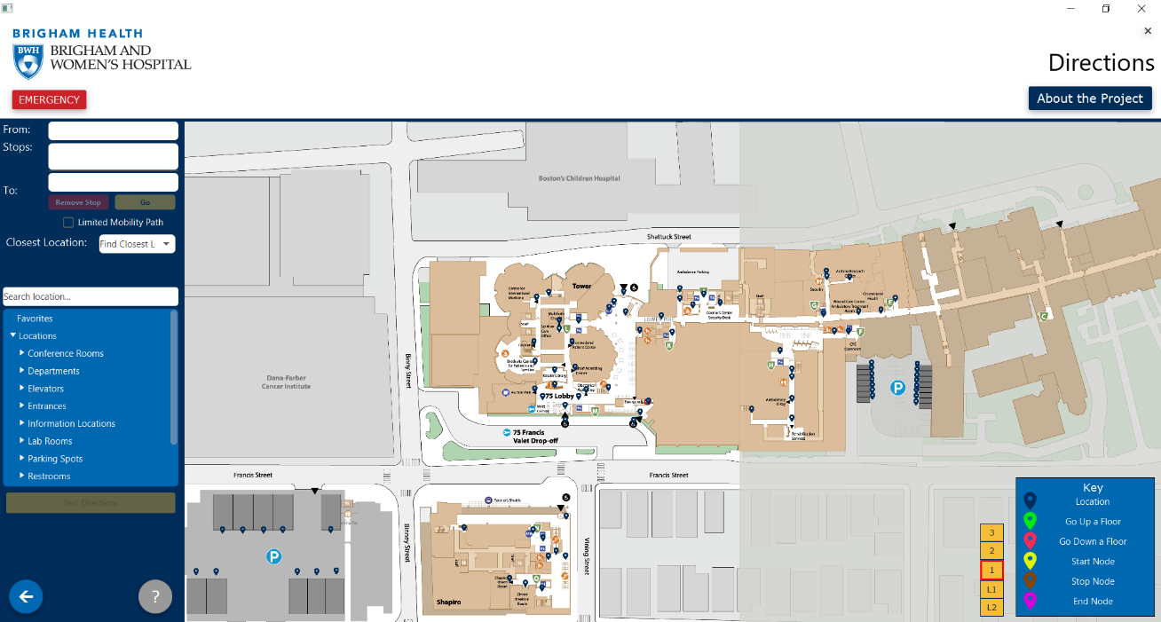 Figure 1.1: Directions Page

Closest Location Dropdown

Node Icon

Tree View

### 1.1.2 Using the Tree View

This section will teach you how to set start and end locations on the *Directions* page by using the tree view on the left side panel (as seen in Figure 1.1). The tree view organizes all the locations by category and allows you to search through all of the nodes.

1. Select your starting location by searching for the name in the **Search Location** bar (Figure 1.2) or by clicking on the correct category and scrolling to your desired node (Figure 1.2).
2. On the popup that appears on the map (Figure 1.3), select **Set Start Location**.
3. Repeat steps 1 and 2 for your end location.
4. 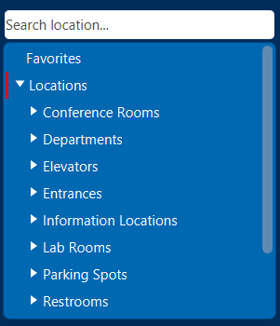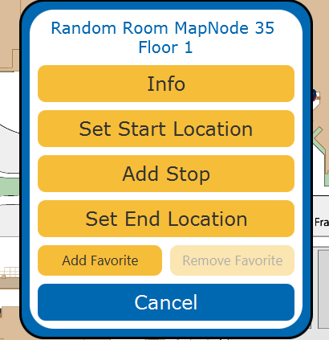Select **Go.**

Figure 1.2: Tree View Closeup Figure 1.3: Map Popup Closeup

### 1.1.3 Finding the Closest Location

This section will teach you how to set the end location to the closest possible location in a given category. These categories include restrooms, restaurants, service desks or entrances.

1. Set your start location by following the steps in Section 1.1.1 or 1.1.2
2. Select your desired location type from the **Choose Location Dropdown** (as seen in Figure 1.1).
3. Select **Go**.

## 1.2 Adding Stops

This section will teach you how to add stops to your route. These stops will be added into your directions in the order that you add them.

1. Set your start and end locations through any of the methods discussed in Section 1.1.
2. Find your desired stop through the tree view or on the map and click on it.
3. Select **Add Stop** on the map popup**.**
4. Select **Go**.

## 1.3 Accessibility Settings

In this section, you will learn how to make the directions accessible for those with impaired mobility. When the limited mobility path is activated, it will only use elevators when changing floors, not stairs. The default setting is for the path to use the closest option, whether it be elevator or stairs.

To enable this feature, check the **Limited Mobility Path** checkbox, as shown in Figure 1.3.

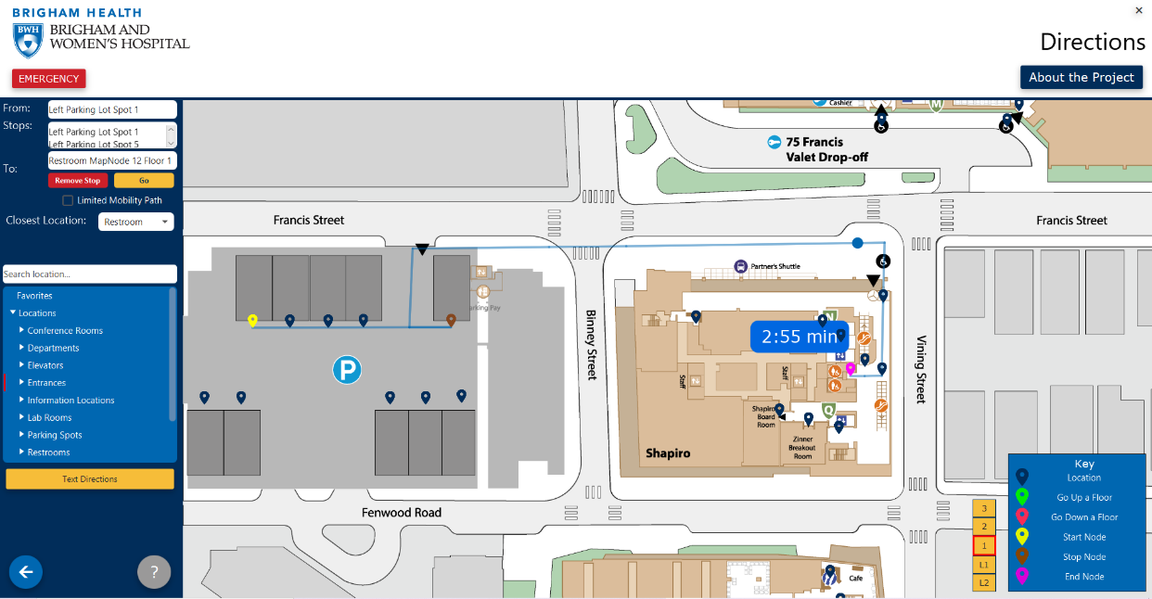Figure 1.3: Limited Mobility Path Checkbox Location

Limited Mobility Checkbox

## 1.4 Favorite Locations

When signed in, the application allows you to save favorite locations so that you may access them easier. These will appear under the **Favorites** category in the tree view on the side panel of the map.

To navigate to a favorite location, please follow the steps in Section 1.1.2, or to add a stop at your favorite location, please follow the steps in Section 1.2.

To remember where you parked, you may favorite your parking spot from the list. You can only favorite one parking spot at a time.

### 1.4.1 Saving Favorite Locations

This section will teach you how to save a location to your favorites.

1. Select your desired node by clicking on the **Node Icon** on the map or by accessing it through the tree view.
2. On the popup that appears on the map, select **Add Favorite.** This node will now appear in your favorites category.

### 1.4.2 Removing Favorite Locations

This section will teach you how to remove a node from your list of favorites.

1. Select the node that you would like to remove from the favorites category in the tree view.
2. On the popup that appears on the map, select **Remove Favorite.** This node will no longer appear in your favorites category.

## 1.5 Using Text Directions

After you have generated a path, you will be able to display text directions on your screen to assist you in finding your destination. In this section, you will learn how to use and view the text directions provided for your path.

### 1.5.1 Viewing Text Directions

This section will teach you how to view the text directions after a path has been generated. Please follow the steps in Section 1.1 to create a path before beginning these steps.

1. Select the **Text Directions** button, as shown in Figure 1.4.
2. The directions will highlight the current section of the path. Once you have followed that direction, select **Next** (seen in Figure 1.4) to highlight the next instruction and section of the path that you are following.
3. To go back a step, press the **Back** button (seen in Figure 1.4).
   1. If you want to go all the way back to the beginning, select **Restart**.
4. Once you have completed the directions, or you no longer want to view them, select **Close** to exit the popup.

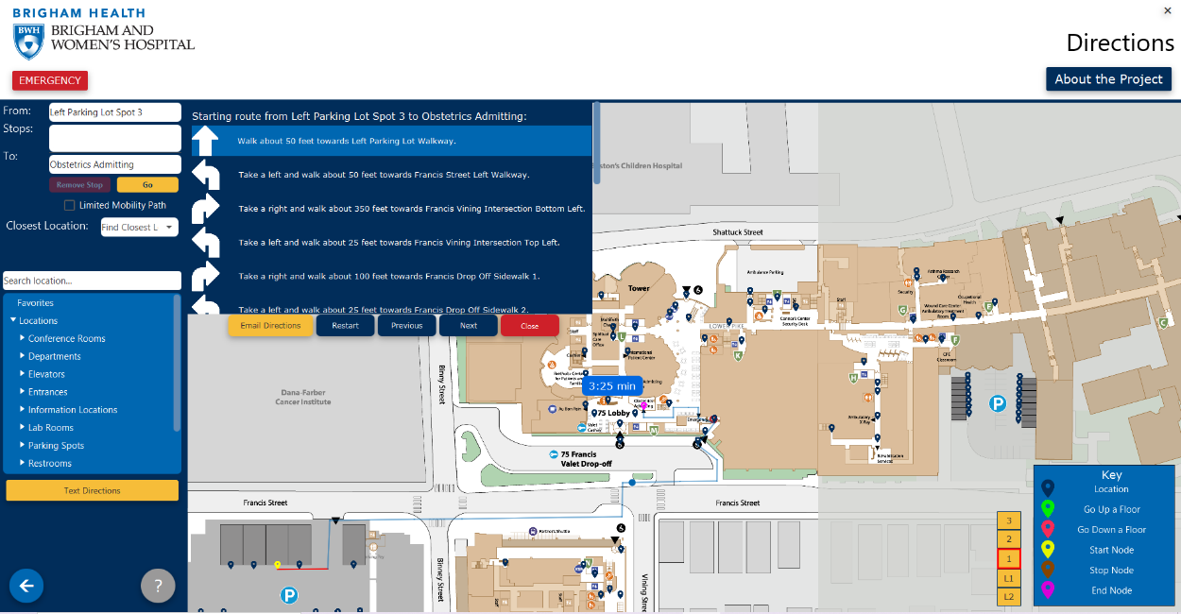

Show Text Directions

Figure 1.4: Text Directions

### 1.5.2 Saving Text Directions

This section will teach you how to email the directions to yourself so that you may view them later.

1. Open the text directions using the steps in Section 1.5.1.
2. Select **Email Directions.**
3. You will receive an email with the text directions to the email that you created your account with shortly after pressing the button.

## 1.6 Administrator Pathfinding Abilities

System administrators are allowed to change the pathfinding algorithm used to generate the paths. This setting is located in the sidebar on the *Directions* page.

There are five algorithms to choose from, each with separate methodology for creating a path. In general, the most efficient algorithm will be A*, and the least will be Depth First Search (DFS). To assist you in selecting the best algorithm for your specific needs, the following are definitions of the algorithms and how they work to generate paths.

**Depth First Search (DFS)**: This algorithm starts with the input starting node and finds the neighbors of this node. It then searches through all of the edges and nodes associated with the first neighbor. If it finds a path to the end point, then it returns this path. If not, then it moves to the next neighbor to the starting node.

**Breadth First Search (BFS)**: This algorithm starts with the given starting node and searches through the neighbors to see if they are the end node. It repeats this for each level of nodes until it eventually finds the end location. It returns the path that it took through each level of neighbors.

**Best First Search (BestFS)**: This algorithm starts with the given starting node and investigates each of its neighbors to see which is closer to the end location. It calculates the distance to the end node using the diagonal (Euclidean) distance to the end node.

**Dijkstra:** This algorithm searches through each node on the graph until it finds the end node. It stores how long each the potential paths are and returns only the shortest one.

**A*:** This algorithm combines the distance away from the end node and the calculated weights of taking each path. This way, the path returned is the shortest and most efficient.

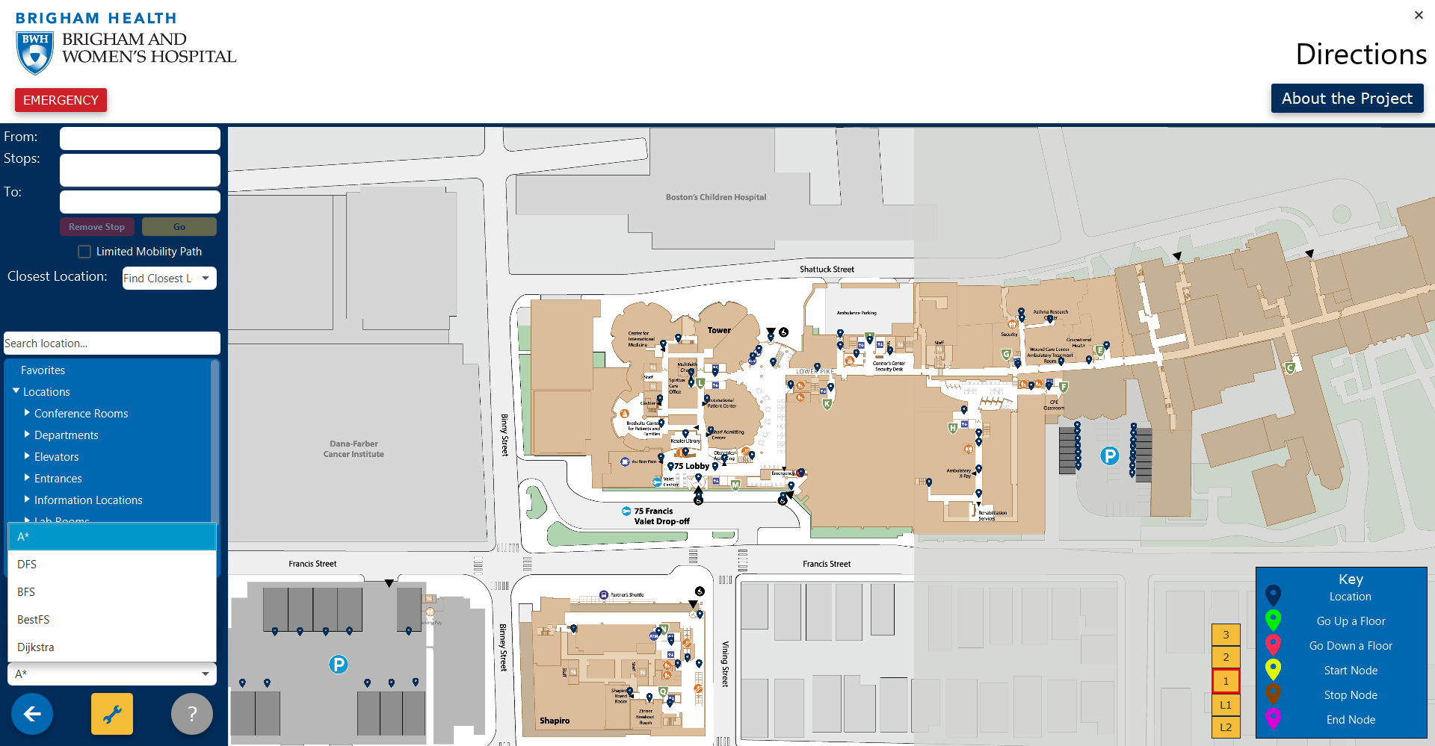

Figure 1.5 Pathfinding Algorithm Selection

## 1.7 Troubleshooting

This section will provide steps to correct common issues with the pathfinding functionality.

### 1.7.1 Generating another path/Adding an Extra Stop

If you have entered a new location to the path and it does not update, first ensure that you have pressed **Go**.

If that does not work, press the **Back** button to exit the *Directions* page. Then, press the **Directions** button to return to the page.

### 1.7.2 Unable to Favorite Parking Spot

If you are trying to favorite your current parking spot, but it will not favorite, first view all your favorites. Remove any other parking spaces from that list and try adding your current parking spot to the list.

### 1.7.3 Not Receiving Text Directions Email

If you have pressed the **Email Directions** button, but have not received an email, go to your account settings. Ensure that the email address that you have entered is correct.

If it is correct, then try sending the text directions again. Ensure that you are connected to the internet.

# Chapter 2: Map Builder

In this chapter, you will learn how to use and troubleshoot the map builder. Only system administrators are allowed to edit the map. To navigate to this page, first ensure that you are on the home screen and then select the **Directions** button.

## 2.1 Adding a CSV File

In this section, you will learn how to add a new CSV file to the map.

1. Select the **Load** button.
2. 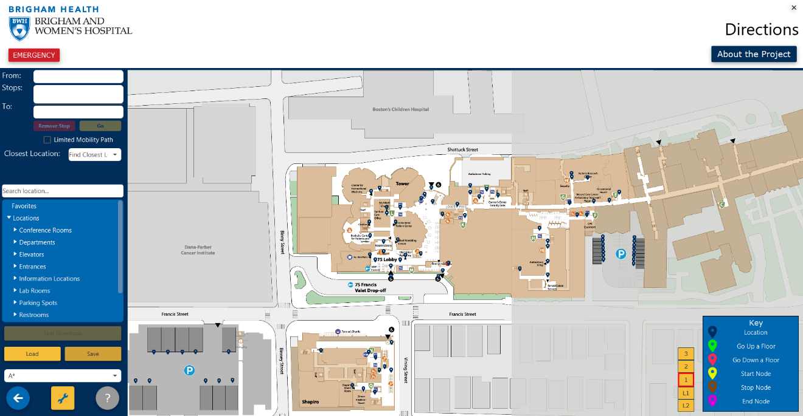Locate your file in your file system and select **Open**.

Load and Save CSV Buttons

Graphical Map Editor Button

Figure 2.1: Administrator Directions Page

To save your CSV file to a new file location, select **Save** and then select the folder in which you would like to save the file.

## 2.2 Graphical Map Editor

In this section, you will learn how to edit the map CSV file using the G*raphical Map Editor*. To access this, select the edit, or wrench, button on the *Directions* page, which can be seen in Figure 2.1.

### 2.2.1 Adding Nodes

This section will teach you how to use the *Graphical Map Editor* to add new nodes to the map. To begin, please ensure that you are on the *Graphical Map Editor* page, which can be seen in Figure 2.2.

1. Move your cursor to the location where you would like to add the node.
2. Double click with your mouse on that spot. An *Add a Node to the Map* popup will appear (Figure 2.2).
3. Fill in each field on the popup. The floor and coordinates fields will be filled out for you.
4. 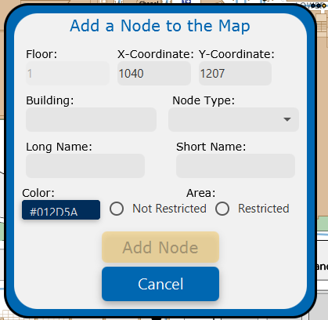Select **Add Node.** Your node should now appear on the graph.

Figure 2.2: Add Node Popup

You may also add nodes on existing edges. To do so, use the following steps.

1. Select the location on the edge where you would like to add the node.
2. From the popup that appears, select **Add Node.** It will take you to the same *Add a Node to the Map* popup from the previous instructions (Figure 2.2).
3. Fill in each field on the popup. The floor and coordinates fields will be filled out for you.
4. Select **Add Node**. Your node should now appear on the edge.

### 2.2.2 Editing Nodes

This section will teach you how to edit existing nodes on the map. There are two ways to edit the nodes. The first method allows you to edit all of the information about the node, and the second only the coordinates of the node.

1. Select the node that you would like to edit.
2. On the popup that appears (as seen in Figure 2.3), select **Edit Node.** This will bring you to the *Edit a Node to the Map* popup, which looks the same as the popup in 2.2.1. All of the fields will be filled in with their current values.
3. Edit the necessary fields.
4. Select **Update Node.**

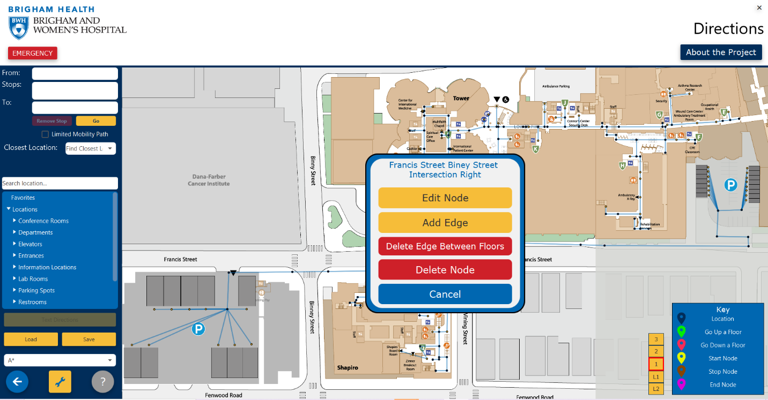

Figure 2.3: Graphical Map Editor with Node Selected

If you need to change the location of a node:

1. Using your mouse, click on the node that you would like to move and drag it to its new location.

### 2.2.3 Adding Edges

This section will teach you how to add edges between nodes on the map.

1. Select the node that you would like the edge to start at.
2. From the popup (which can be seen in Figure 2.3), select **Add Edge**. The popup will disappear.
3. Select the node that you would like the edge to end at.
4. Confirm that you would like to add the edge by selecting **Yes.**

### 2.2.4 Deleting Nodes and Edges

This section will teach you how to delete nodes and edges from the map.

1. Select the node or edge that you would like to delete.
2. From the popup on the map (which can be seen in Figure 2.3) select **Delete**.
3. Confirm your deletion by selecting **Yes.**

## 2.3 Troubleshooting

This section will provide steps to correct common issues with the map editing functionality.

### 2.3.1 Loading CSV Causes Errors in Application

If you try to load a new CSV file into the map and the map does not look as you expected or there are other strange effects, ensure that your CSV file is in the correct format. Then, restart the application and attempt to upload the reformatted version.

### 2.3.2 Cannot Add Node

If you are attempting to add a node but it will not allow you to press **Add Node**, review the information that you have typed is correct. Ensure that you have selected an option from the **Node Type** dropdown and have not manually typed a node type in.

### 2.3.3 Cannot Add Edge

If you are attempting to add an edge, but it will not add, first ensure that you deselect the starting node. Select the node again and from the popup, select the **Add Edge** button again. When the popup disappears, ensure that you only click on the end node and not on an empty space on the map. Once you select the next node, a popup should appear. If this now appears, select **Yes**.

# Chapter 3: Service Requests

In this chapter, you will learn how to create, use and troubleshoot service requests. Only staff members and administrators can access the service requests. To navigate to the directory, first ensure that you are logged in and then select the **Service Requests** button. You will be brought to the screen shown in Figure 3.1.

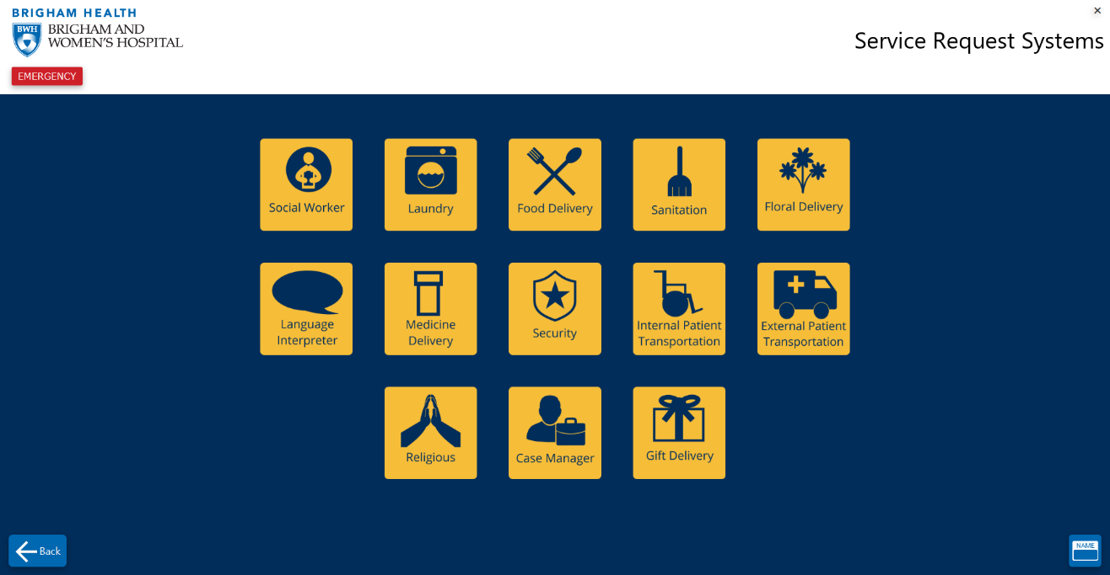System administrators are able to see all of the existing service requests, while staff members are only able to see those that they created or that were assigned to them.

Figure 3.1: Service Request Directory

## 3.1 Creating a Service Request

This section will teach you how to create a new service request. Please ensure that you are on the *Service Request Systems* page.

1. Select the type of service request by clicking on the corresponding button on the *Service Request Systems Page*. This will bring you to a form to fill out similar to the one shown in Figure 3.2.
2. Fill in all of the blanks. The submit button will be inactive until each field is completed.
   1. Ensure that each field is filled in correctly, otherwise, in some cases, it will not accept the information.
3. Select **Submit.** You should be taken to the *Successfully Submitted* screen.

If you need more information about what to enter into a field:

1. Click on that field
2. 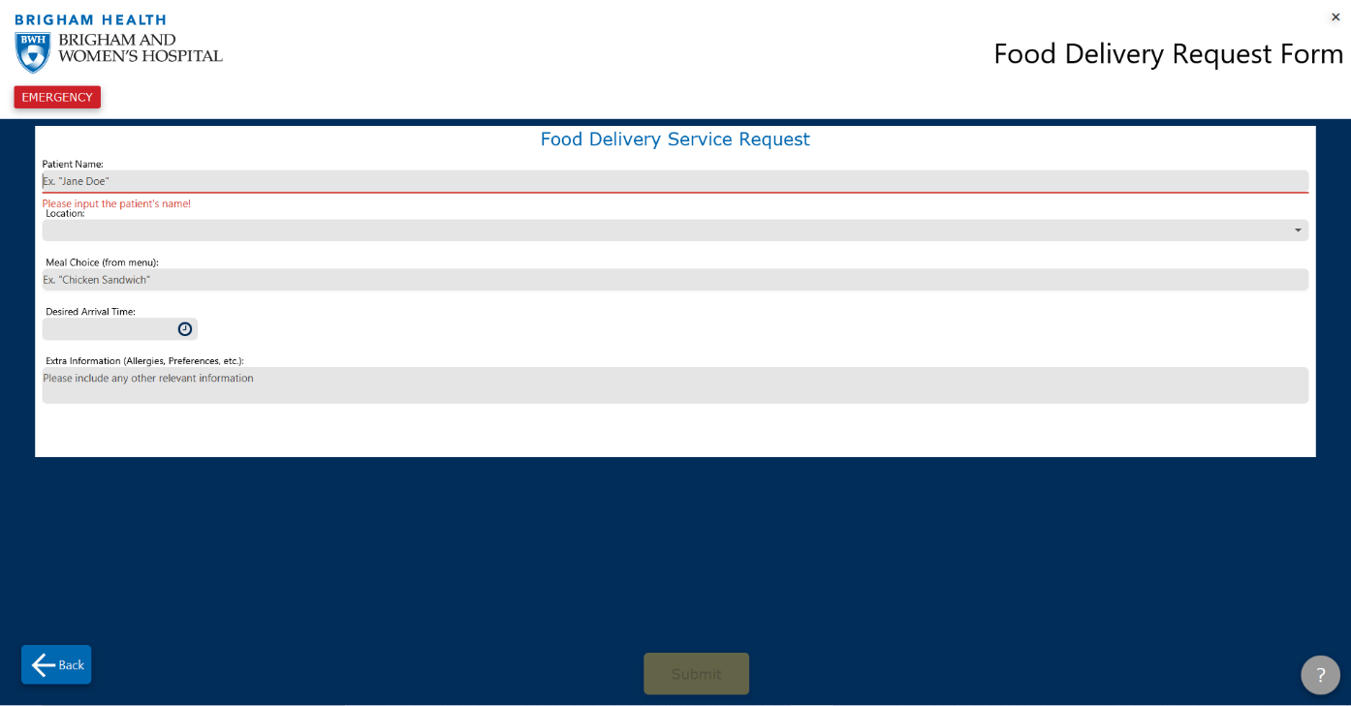Click on another field. Red text will appear that describes the information that is needed in that field.

Figure 3.2: Service Request

## 3.2 Assigning a Service Request

This section will teach you how to assign a service request to be completed by a staff member. Staff members can only do so to requests they created or that were previously assigned to them, and administrators may assign a staff member to any existing service request.

These steps must be completed in the *Service Request Database* page. To get to this page, log in and select the **Request Database** button.

1. Find the service request that you would like to assign in the table.
2. In the *Assigned To* category of that row, right click. A small popup will appear (Figure 3.3) that will allow you to select a staff member or remove a staff member from the service request.
3. Click on the name of the staff member that you would like to assign the request to. It will now appear in their service request database.

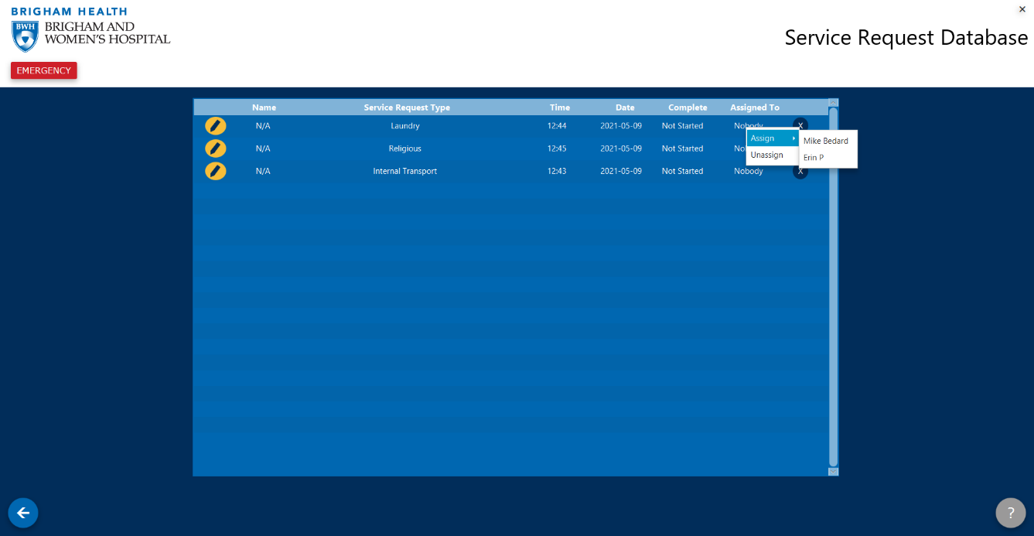Figure 3.3: Assigning a Staff Member to a Service Request

## 3.3 Completing a Service Request

Similar to assigning a service request, a request can be marked as not started, in progress, or complete. This section will teach you how to change the status of a service request.

Just as with assigning a service request, staff members may only change the status of requests they created or that were assigned to them, and administrators can do so for any existing request.

1. Find the service request that you would like to change the status for in the table.
2. In the *Complete* category of that row, right click. A small popup will appear (similar to the one in Figure 3.3) that will allow you to select the status of a service request. The options are **Not Started, In Progress** and **Complete.**
3. Click on the status that you would like to set the service request to. It should now display that status in the *Service Request Database.*

## 3.4 Editing a Service Request

This section will teach you how to edit an existing service request. The staff and administrator permissions remain the same as in the previous sections for this functionality.

1. Select the **Edit** button (as seen in Figure 3.4). It should bring you to the *Service Request Form* page with the current information filled into the fields.
2. Update the necessary fields, ensuring that the information is still valid.
3. Select **Submit**. You should be taken to the *Successful Submission* page. The information in your form should be updated.

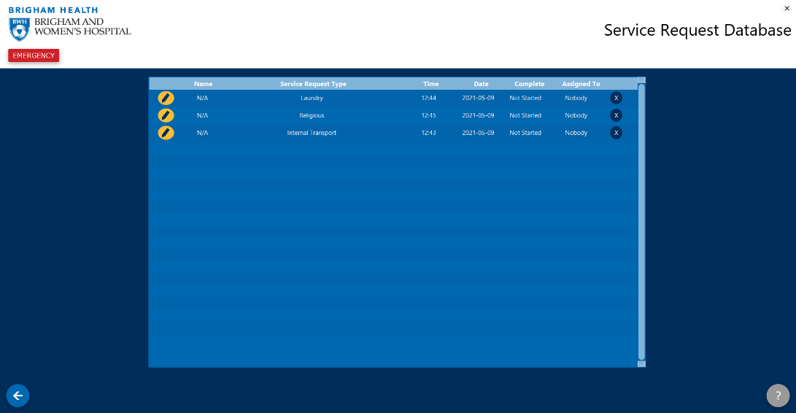

Delete Button

Edit Button

Figure 3.4: Service Request Database Buttons

## 3.5 Deleting a Service Request

This section will teach you how to delete an existing service request. The staff and administrator permissions remain the same as in the previous sections for this functionality.

1. Select the **Delete** button (as seen in Figure 3.4).
2. Your request should no longer appear in the *Service Request Database.*

## 3.6 Troubleshooting

This section will provide steps to correct common issues with the service requests.

### 3.6.1 Unable to Press Submit

If you have filled out the service request form, but the **Submit** button is not able to be pressed, use the following guidelines to ensure that all the fields are correct.

* For time selections, ensure that the start time is after the end time.
* For calendar selections, ensure that you selected a date from the calendar, as opposed to manually typing in the date.
* For dropdown boxes, ensure that you selected an option from the dropdown, as opposed to manually typing in the box.
* Ensure that none of the fields are marked with red text above them. If they are, use the text to determine the correct information for that field.

### 3.6.2 Unable to See Request in Database

If you are a staff member and can no longer see a request that was assigned to you, the request was likely removed by an administrator. Exit the *Service Request Database* and re-enter. If the request still does not appear, it has been assigned to another staff member or deleted by an administrator.

# Chapter 4: Google Maps Integration

In this chapter, you will learn how to use the Google Maps integration to get directions from anywhere to the hospital. You do not need to be logged into the app to use this feature, and it is available for any level of user. To access this page, ensure that you are on the home page and then select the **Google Maps** button.

## 4.1 Getting Directions

This section will teach you how to use the *Google Maps Directions* page to find directions from any location to the hospital. Please ensure that you are on the correct page, as described above.

1. Enter your starting location. You must enter the address, city and state onto this line.
2. Select your end location from the dropdown.
3. Select **Submit**. Your route should appear in blue on the map.

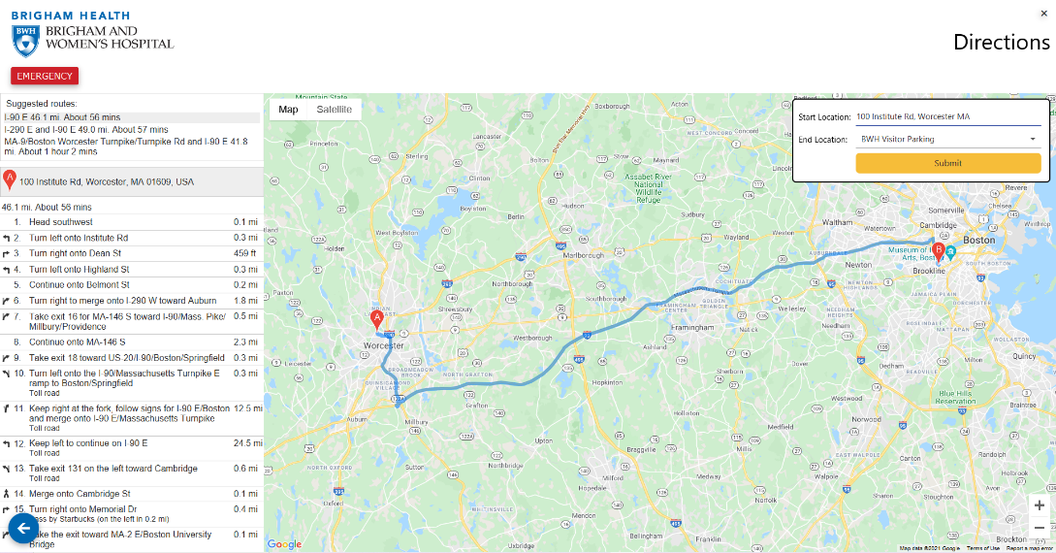Once you have entered the directions, you will be able to see different possible routes as well as text directions to follow for the selected route. To change routes, click on your preferred route under the *Suggested Routes List* (which can be seen in Figure 4.1). By clicking on a specific text direction, it will highlight where you are supposed to follow that instruction on the map.

Suggested Routes

Figure 4.1: Google Maps with Filled-Out Route

## 4.2 Troubleshooting

This section will provide steps to correct common issues with the Google Maps functionality.

### 4.2.1 Path Does not Appear

If you have input a start location and selected a hospital entrance, but a route does not appear, ensure that your address is complete. If there are multiple addresses found with the same information that was input, the software can not create a route. Input your full address, including street, city, state and zip code.

If this does not correct it, use a nearby address to generate a different path.

# Chapter 5: Text-to-Speech

In this chapter, you will learn how to use the text-to-speech function within the application. This feature is intended for those who are visually impaired, so that they can navigate through the app without reading the text.

## 5.1 Enabling Text-To-Speech

Text-to-speech is available for every user, including guests. This section will teach you how to enable and disable this feature.

1. For guest users, ensure that you are on the *Home* page. If you are logged in, ensure that you are on the *Directory* page.
2. Select **Settings**.
3. Click on the **Text-to-Speech** toggle to switch it on or off, as seen in Figure 5.1.

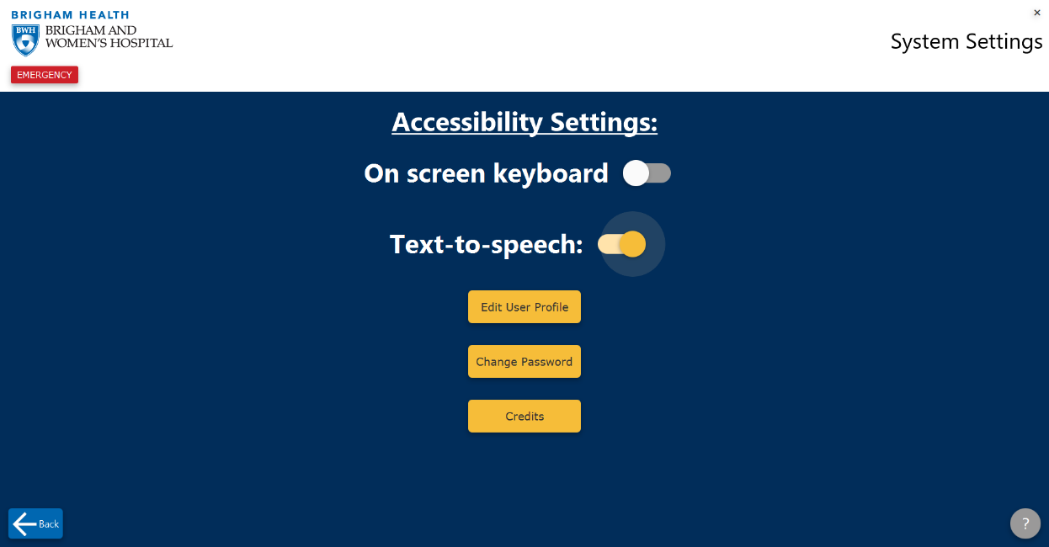Figure 5.1: Enabling Text-to-Speech

## 5.2 Navigating the App Using Text-to-Speech

In this section, you will learn how to use the text-to-speech functionality once you have enabled it. To turn on the text-to-speech feature, please follow the steps in Section 5.1.

### 5.2.1 Selecting buttons

This section will teach you how to use the text-to-speech feature to select buttons to navigate through the app. Text-to-speech will always start in the top left corner and progress down the screen.

To move to the next button, press the **Tab** key on your keyboard.

To select the current button, press the **Spacebar**.

### 5.2.2 Filling in Text Fields

When filling in fields that require text, the text-to-speech feature will read the question aloud and place the cursor inside of the box. To complete the field, type in what the field asks for and press the **Tab** key as normal to proceed to the next item.

## 5.3 Troubleshooting

This section will provide steps to correct common issues with the text-to-speech functionality.

### 5.3.1 Unable to Exit Text Entry

If the **Tab** button does not exit a text entry field, use the cursor to select the next field. The text-to-speech will read the label for the new field once it is selected.

# Chapter 6: On screen Keyboard

In this chapter, you will learn how to use the on screen keyboard functionality. This functionality allows you to use your mouse to select keys on your screen to fill in text fields. Every user is permitted to use this feature, including guests.

## 6.1 Enabling the On Screen Keyboard

This section will teach you how to enable and disable the on screen keyboard.

1. For guest users, ensure that you are on the *Home* page. If you are logged in, ensure that you are on the *Directory* page.
2. Select **Settings**.
3. Click on the **On Screen Keyboard** toggle to switch it on or off.

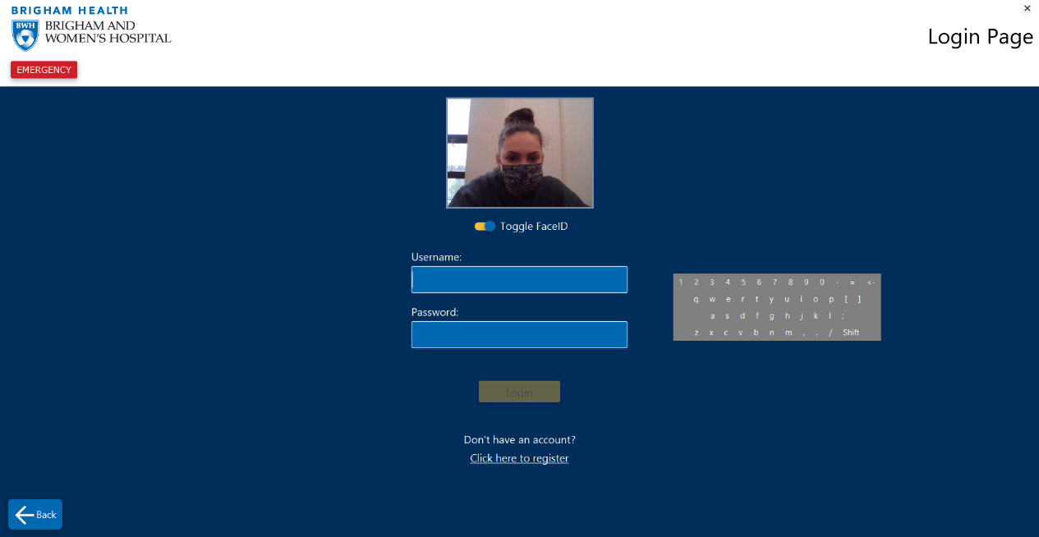Figure 6.1: On Screen Keyboard Enabled

## 6.2 Using the On Screen Keyboard

This section will teach you how to use the on screen keyboard after it has been activated.

To move the keyboard around on the screen, move your cursor to an area within the keyboard that does not have a letter (one of the sides or corners). Click and hold while you drag your cursor and the keyboard will follow.

To use the keyboard, first ensure that you have entered into the text field that you would like to type in. Then, using your mouse, click on the letters that you would like to enter.

## 6.3 Troubleshooting

This section will provide steps to correct common issues with the on screen keyboard functionality.

### 6.3.1 Keyboard Blocks Objects on the Page

If the keyboard is blocking objects on the page, follow the steps in Section 6.2 to move it around on the screen, as necessary.

### 6.3.2 Keyboard is Not Typing in Text Field

If you have selected the text field but when clicking on the keyboard buttons, nothing appears in the text box, then select the text box again and try to type in it again.

If this does not work, select another field and reselect the original field.

# Chapter 7: Face ID

In this chapter, you will learn how to use the Face ID feature to log into the application. Upon recognizing your face, this feature will automatically fill in your login information for you.

## 7.1 Creating an Account with Face ID

This section will teach you how to enable Face ID on your account. This can only be done during account creation.

1. From the home screen, select **Register**. You will be brought to the page shown in Figure 7.1.
2. Input your information into the each of the fields.
3. Ensure that you are in a well-lit area and that you are looking at your device straight-on.
4. When the green box appears around your face, select **Take Picture.**
5. Select **Register.** You now have an account and can use Face ID to log in.

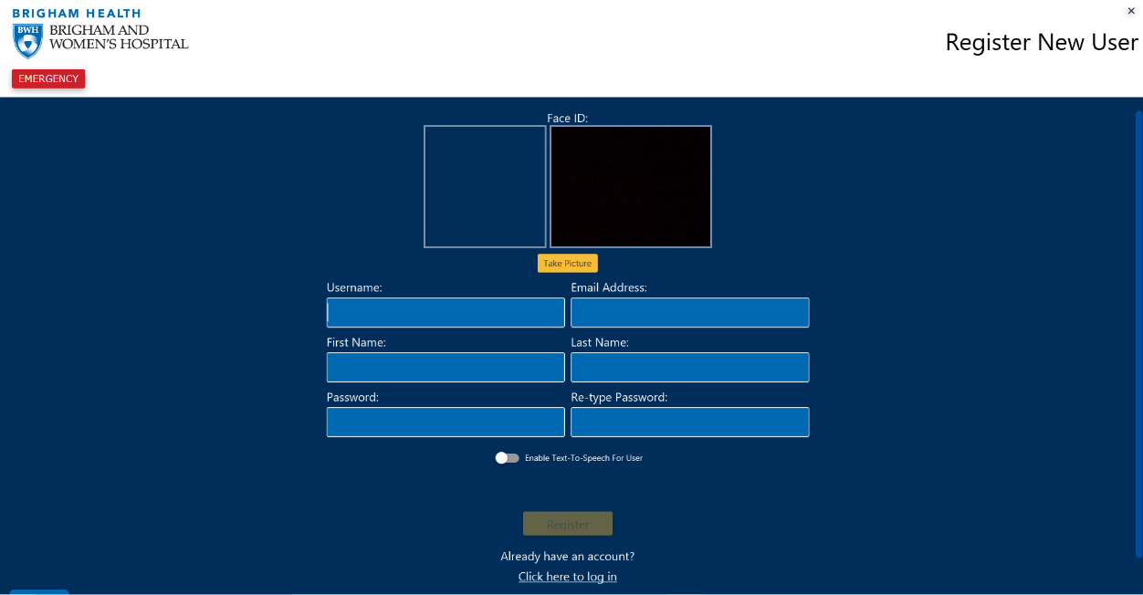Figure 7.1: Register with Face ID

## 7.2 Logging in with Face ID

To log in with Face ID, you must create an account with Face ID enabled. Please ensure that you have followed the steps in Section 7.1 before attempting to use Face ID to log in.

1. From the home screen, select **Log In.**
2. Ensure that you have proper lighting and are looking at the camera straight-on.
3. As soon as the Face ID recognizes you, it will automatically fill in your username.
4. Enter your password.
5. Select **Log In.**

## 7.3 Troubleshooting

This section will provide steps to correct common issues with the Face ID login functionality.

### 7.3.1 Unable to Recognize Face

If you have been able to sign into your account with Face ID before, try adjusting your angle and lighting and try logging in again.

If this does not work, please log in normally.

# Chapter 8: Chat Bot

In this chapter, you will learn how to use each of the different functionalities of the chat bot feature. The chat bot is able to assist you in many ways in the application. It is always located in the bottom right corner of the application.

## 8.1 Navigating the Application

This section will teach you how to navigate to different pages of the application using the chat bot.

1. Open the chat bot by clicking on the **How may we assist you?** button in the bottom right corner of the screen, if it is not opened already. The chat box should open and your screen should look like Figure 8.1.
2. Type in which part of the application you would like to navigate to. For example, to be taken to the login page, type ‘log in’.
3. Press **Enter**.
4. You will receive a message confirming that you would like to be taken to that page.
5. Type ‘yes’ to confirm.
6. Press **Enter.**
7. You will automatically be taken to the desired page.

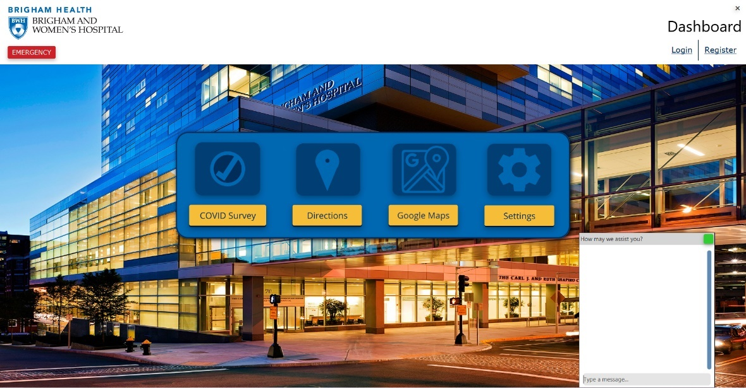Figure 8.1 Chat Bot Opened

## 8.2 Asking for Help

This section will teach you how to get help within the app from the chat bot. The chat bot can answer many questions that you may have about the content or functions on a specific page.

If you have navigated to a page and are confused about information on that page:

1. Open the chat box if it is not already open by clicking on the **How may we assist you?** button on the bottom right of your screen. The chat box should open and should appear like the one in Figure 8.1.
2. Provide a response using one of the keywords for that page.
3. Press **Enter**.
4. The chat bot will ask you if you need any assistance.
5. Type ‘yes’.
6. Press **Enter.**
7. The chat bot will provide you with more information regarding the functionality of that specific page and what information is necessary to put in.

If you used the chat bot to navigate to a page, it will automatically ask you if you need assistance with anything on that page. Follow these steps to receive help:

1. Once you have navigated to the page, the chat bot will ask you if you need any assistance. Even if you have been on that page for a while or have closed the chat box, it will still appear as the most recent message.
2. Type ‘yes’.
3. Press **Enter.**
4. The chat bot will provide you with more information regarding the functionality of that specific page and what information is necessary to put in.

## 8.3 Checking Account

This section will teach you how to use the chat bot to check that you are signed in, and find out information about your account.

1. Open the chat box if it is not already open by clicking on the **How may we assist you?** button on the bottom right of your screen. The chat box should open and should appear like the one in Figure 8.1.
2. Type “Who am I?”
3. Press **Enter.**
4. The chat bot will provide you with your first and last name, as well as your username.

## 8.4 Troubleshooting

This section will provide steps to correct common issues with the chat bot functionality.

### 8.4.1 Not Recognizing Input

If you are typing in the chat bot and it responds with an unexpected answer or “I’m not equipped to answer that”, then please try the following:

1. Rephrase your input. The chat bot will only be able to assist you if you use the keywords that it has learned. Rephrase your statement so that it uses different words for the chat bot to analyze.
2. If you are looking for help on a specific page and the chat bot will not help you, type in the name of the page you are on. If you are using the google maps, please type in “Google Maps” rather than directions.

### 8.4.2 Unable to Access Directions Page

The application will not open the *Directions* page until you have taken a COVID survey and it has been approved by a staff member. If you are unable to access the *Directions* page, your COVID survey is still pending approval from a nurse.

# Chapter 9: Arcade Games

In this chapter, you will learn how to access the arcade games included in the application. You can access these games while you are waiting for your COVID survey to be approved. The three games that are available are: Snake, Pac-Man and Brick Breaker.

## 9.1 Accessing the Games

This section will teach you how to access the arcade games in the application. You will only be able to access them until your COVID Survey has been approved.

1. Click on either the **Directions** button or **COVID Survey** button.
2. Fill out each field in the survey.
3. Select **Submit.** You will be brought to a *Form Submitted* screen (Figure 9.1).
4. Select **Waiting Room.** You will be brought to a menu with the three arcade games.
5. 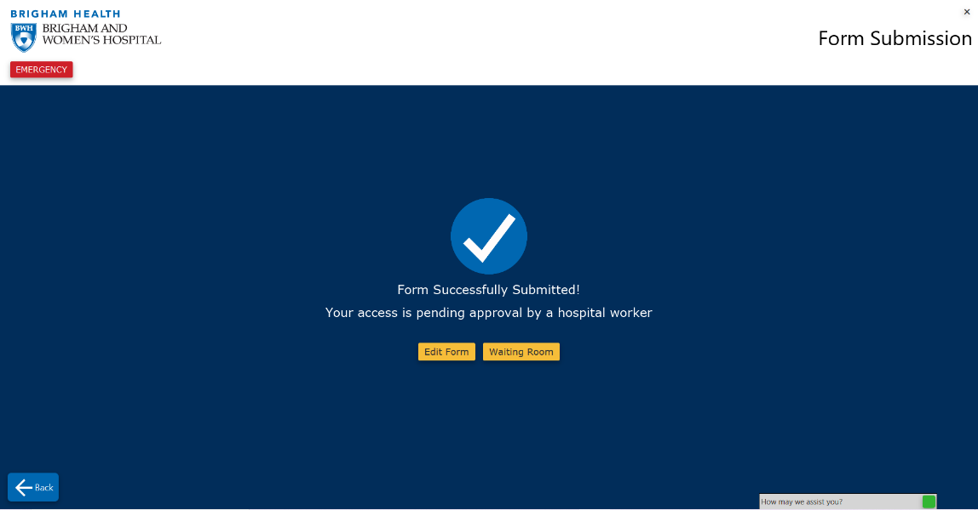Select which game you would like to play. It will pop up in a new window.

Figure 9.1: Form Submitted Screen

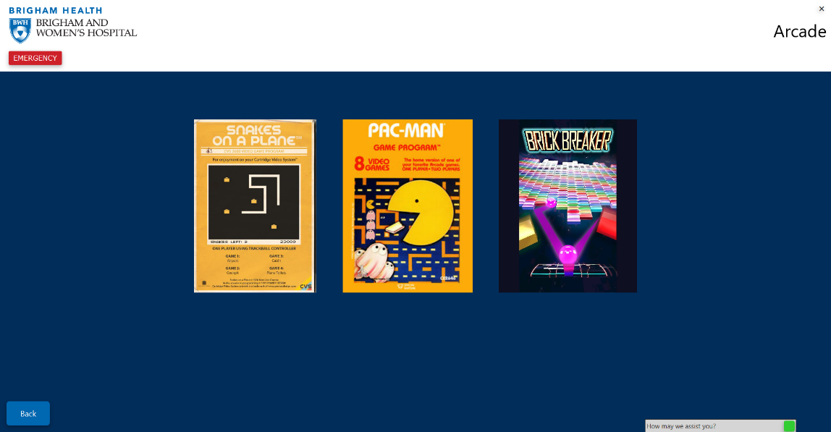

Figure 9.2: Games Menu

## 9.2 Playing the Games

In this section, you will learn how to play the games on your device once you have accessed them. To access the game menu, follow the steps in Section 9.1.

### 9.2.1 Snake

This section will teach you how to play the game Snake in the application.

1. To begin, ensure that you are on the *Games Menu* page (Figure 9.2).
2. Select the **Snakes on a Plane** image.
3. Use your arrow keys to move the snake around the screen.
4. If you lose, you will see the *Game Over* screen.
5. Exit out of the *Snake* popup. To play again, open the game back up by performing these steps again.

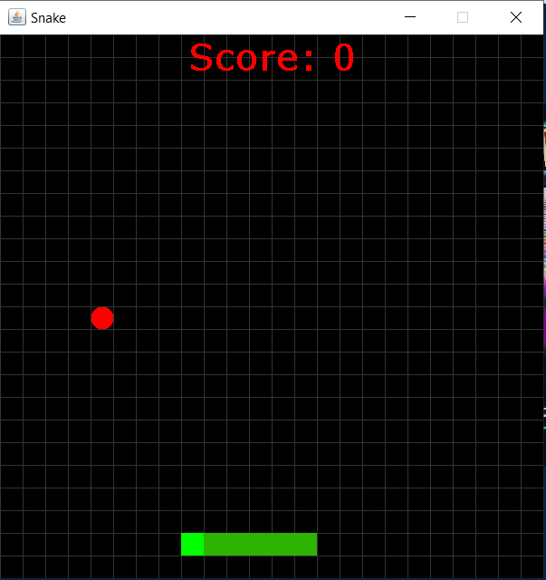

Figure 9.3: Snake Game

### 9.2.2 Pac-Man

This section will teach you how to play the game Pac-Man in the application.

1. To begin, ensure that you are on the *Games Menu* page (Figure 9.2).
2. Select the **Pac-Man** image.
3. Press any **arrow key** to begin.
4. Use your arrow keys to move the Pac-Man around the screen.
5. If you lose, you will see the same screen as when you opened the app. Repeat steps 2-4 to replay, or exit the popup to play a different game.
6. Exit out of the *Pac-Man* popup. To play again, open the game back up by performing these steps again.

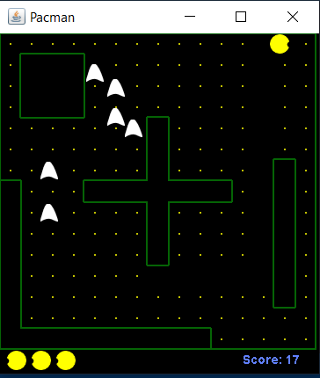

Figure 9.4: Pac-Man Game

### 9.2.3 Breakout

This section will teach you how to play the game Breakout in the application.

1. To begin, ensure that you are on the *Games Menu* page (Figure 9.2).
2. Select the **Brick Breaker** image.
3. Use your **left and right arrow keys** to move the bar on the screen.
4. If you lose, you will see the *Game Over* screen.
5. Exit out of the *Breakout* popup. To play again, open the game back up by performing these steps again.

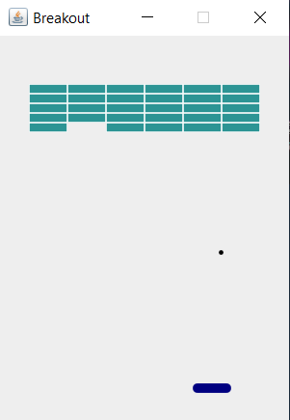

Figure 9.5: Breakout Game